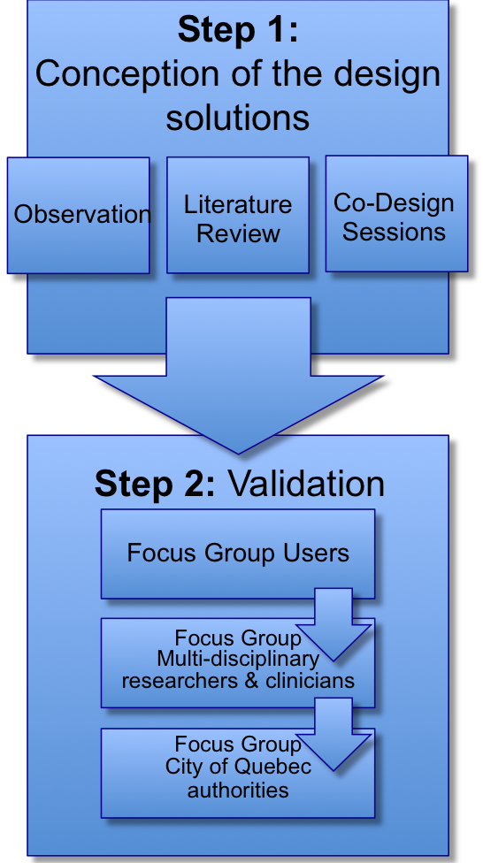

Health condition

Body functions

& structures

Activities

Participation

Environmental factors

Personal factors

Design Solution

Performance

Needs

Materials

Space-plan

Services

Site

Skin

Structure

Safety & Security

Production support

Compliance with laws

Energy & Sustainability

Adaptability

Initial & operational

costs

Basic needs

Functional needs

Local needs

Ecological needs

Strategic needs

Economic needs

Rutten (1996) Model of Integrated Building Design adapted for the research of Winter: Public Enemy #1

World Health Organization (2001) International Classification of Functioning (ICF)

TOTAL DESIGN

Figure I. IFC/MIBD Model adapted to the research on Winter: Public Enemy #1

Figure 2. Co-Design Methodology

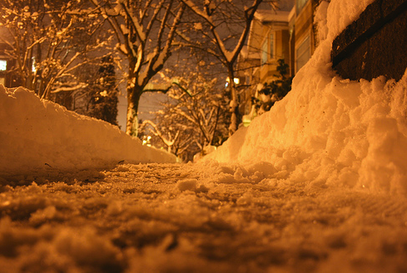

Figure 3. Solution for melting snow in sidewalks

Figure 4. Curb cut during winter months in Quebec Cityt. number of thk i the curb cut it is easier to explain it that way for the priorization of snow removal procedures in the stree

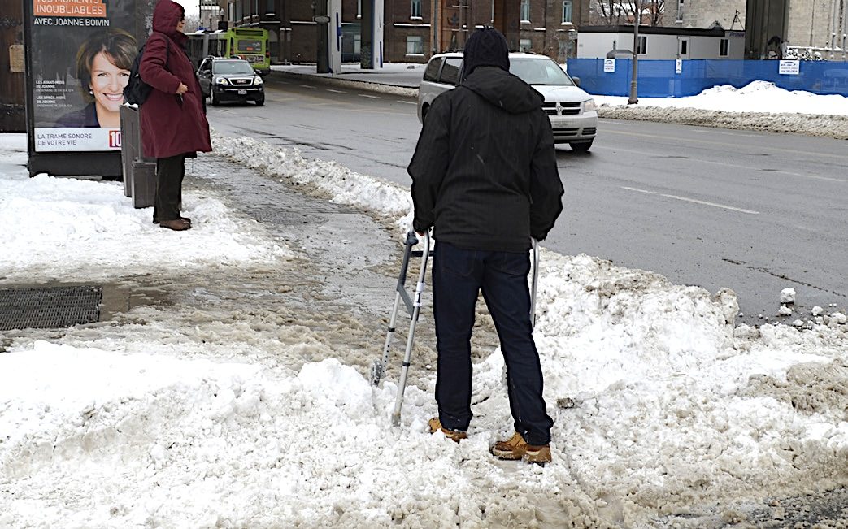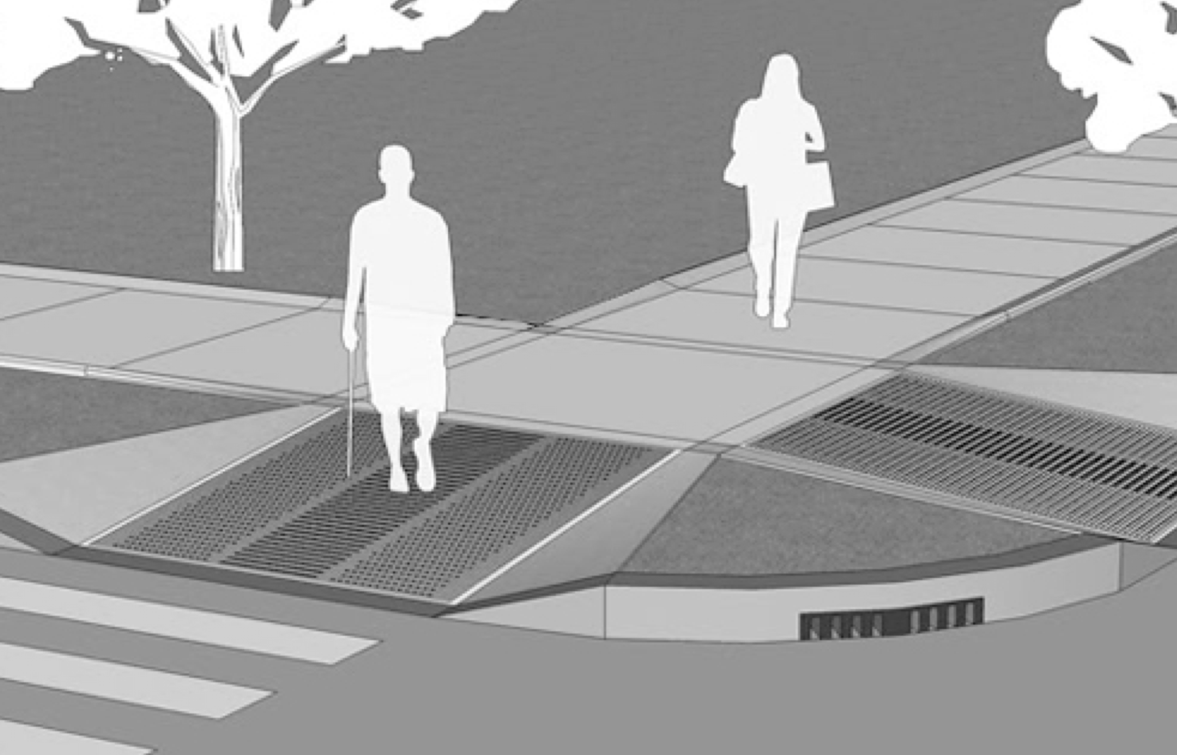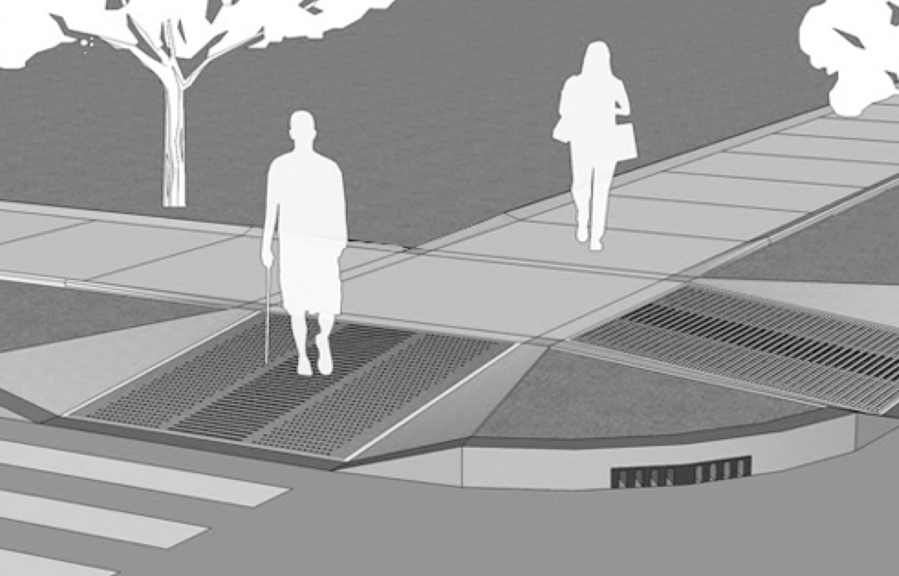

Figure 5. Solution to improve accessibility in street corners